**INDIRA GANDHI DELHI TECHNICAL UNIVERSITY FOR WOMEN**

**(Established by Govt. of Delhi vide act 09 of 2012)**

**Kashmere Gate, Delhi-110006**

[Grab your reader’s attention with a great quote from the document or use this space to emphasize a key point. To place this text box anywhere on the page, just drag it.]

**Information Technology**

**Capstone Project Report**

***FashAura – Dream Design Studio***

**Summer Internship Program: 2025**

**Team Members: Faculty Advisor:**

* Mitashi Dua (08101032024) **Dr.** **Shweta Singhal**
* Srishti Gupta (13501032024)
* Tanishka (14201032024)
* Yukti (15301032024)

**Date of Submission:** July 15, 2025

**Semester:** III

**Table of Contents**

|  |  |  |
| --- | --- | --- |
| **S.No.** | **Section Title** | **Page No.** |
| **1** | **Executive Summary** |  |
| **2** | **Introduction**  2.1 Project Background  2.2 Internship Context  2.3 Project Objectives |  |
| **3** | **Problem Statement**  3.1 Industry Context  3.2 Limitations of Existing Solutions  3.3 Identified Gaps in Current Technologies  3.4 Why FashAura Was Built |  |
| **4** | **Generative AI Methodology**  4.1 Approach  4.2 Technologies Used  4.3 Data Collection & Preparation  4.4 Model Training/Implementation: |  |
| **5** | **Results & Discussion**  5.1 Key Outcomes  5.2 Performance & Evaluation  5.3 Analysis & Interpretation  5.4 Challenges & Solutions |  |
| **6** | **Conclusion & Future Work**  5.1 Conclusion  5.2 Learning Outcomes  5.3 Future Scope |  |
| **7** | **Team Contributions** |  |
| **8** | **References** |  |
| **9** | **Appendices**  9.1 Data Flow Diagram  9.2 Sequence Diagram View  9.3 Landing Page  9.4 Designing Page  9.5 Flowise AI Environment  9.6 Feedback |  |

### **Acknowledgement**

It is with immense gratitude that we extend my heartfelt thanks to **Dr. Shweta Singhal**, our esteemed mentor, for her unwavering support, kind encouragement, and insightful guidance throughout the development of this project. Her mentorship was not just limited to technical supervision, but also included emotional support, creative freedom, and a nurturing approach that made our learning experience both enjoyable and deeply enriching.

Dr. Shweta constantly motivated us to explore new possibilities beyond our initial vision. She encouraged us to think innovatively and helped us recognize the real-world potential of our ideas. Her suggestions opened new directions for our project, pushing us to incorporate features that made the platform more inclusive, engaging, and aligned with current industry trends.

Her sweet and cooperative nature made every discussion feel comfortable and inspiring. Despite her busy schedule, she was always approachable, listened patiently, and offered thoughtful feedback with warmth and empathy. Working under her mentorship was truly one of the most encouraging aspects of our journey, as it taught us the value of curiosity, humility, and collaboration.

We feel genuinely fortunate to have been guided by someone who not only believes in academic excellence but also in empowering her students to grow with confidence and creativity. This project, **FashAura – Dream Design Studio**, is as much a reflection of her encouragement as it is of our efforts.

### **Declaration**

We, the undersigned, solemnly declare that the project titled **“FashAura – Dream Design Studio”** is an original piece of work carried out by us in fulfilment of our academic requirements. This work has been undertaken with sincerity, creativity, and a genuine intent to explore the practical applications of Generative AI in the field of personalized fashion visualization.

We affirm that this project has **not been submitted** to any other institution, authority, or platform for the purpose of evaluation, certification, or academic credit in any form.

We further declare that:

* All the content, data, and insights presented in this report are the **outcome of our own understanding, exploration, and experimentation.**
* Any external content, references, images, or code that has been used to support the project has been **properly cited and acknowledged** to the best of our knowledge.
* We have **maintained academic integrity** throughout the course of this work and **have not indulged in plagiarism, duplication, or unethical means** in any aspect of this submission.
* We accept **full responsibility for the originality, accuracy, and integrity** of the information and design solutions documented in this report.

This declaration is made with utmost respect and gratitude for the opportunity to learn, innovate, and grow through this project.

**Submitted by:**

* Mitashi Dua (08101032024)
* Srishti Gupta (13501032024)
* Tanishka (14201032024)
* Yukti (15301032024)

**Date:** July 15, 2025

**1. Executive Summary**

**FashAura – Dream Design Studio** is a forward-thinking web application that redefines the way fashion concepts are visualized. At its core, FashAura blends the power of artificial intelligence with user-centric design to allow anyone from fashion enthusiasts to aspiring designers to create stunning fashion illustrations based solely on their imagination and natural language input.

The platform leverages **FlowiseAI**, integrating large language and image generation models through API endpoints to transform textual prompts into full-body fashion illustrations. Users can personalize each creation with a rich set of inputs, including **height, body measurements, and skin tone**, ensuring that the final design reflects diverse human attributes with precision and inclusivity.

One of the standout features of FashAura is its **voice-to-text capability** using the Web Speech API, allowing users to speak their design prompts, making fashion creation feel more conversational and interactive. This accessibility feature not only enhances usability but also aligns with modern trends in voice-driven web experiences.

In the latest iteration of the platform, several significant enhancements have been introduced to elevate the user experience:

* A **regenerate with styling tips** button powered by a second Flowise model, offering users intelligent suggestions to refine or evolve their initial ideas.
* A **dynamic chat interface** that mimics real-time conversation with the AI stylist, maintaining a history of user prompts and AI responses in visually distinct chat bubbles.
* A **speech input button** that instantly translates spoken words into creative prompts, making the tool more accessible and fun to use.
* A **gallery section** that archives all previously generated designs in thumbnail format. Users can revisit or re-download any design with a single click, promoting creativity tracking and inspiration.
* A **secure image download system** that fetches and saves designs directly without opening them in the browser, thereby protecting the continuity of the designing experience.
* A visually rich **landing page** featuring an animated image carousel, customer testimonials, themed call-to-actions, and a modal-based login/signup system.
* An always-accessible **feedback button** pinned to the bottom-right corner, linked to a live Google Form, making it easy for users to share suggestions or issues.

Technologically, the frontend is crafted using **HTML, CSS, and vanilla JavaScript**, with a strong emphasis on UI/UX aesthetics. The system communicates with Flowise AI endpoints for prompt handling and image generation, ensuring real-time response and rendering. The overall design philosophy centres on **simplicity, beauty, and function**, ensuring that users regardless of technical background can enjoy the magic of AI-generated fashion.

In a world where digital design and personalization are rapidly converging, FashAura emerges as a trailblazer, offering not just a tool, but an experience. It stands as a testament to how thoughtful integration of AI can unlock creative potential, enabling users to see their imagination come to life on a canvas that celebrates individuality and expression.

**2. Introduction**

**2.1 Project Background**

In an era where AI is reshaping creative industries, one of the most exciting frontiers lies in the realm of digital fashion visualization. Despite significant advancements in online retail and design platforms, most fashion tools remain static and disconnected from user individuality. Consumers often browse fixed catalogues that do not reflect their personality, body features, or aesthetic desires. **FashAura – Dream Design Studio** was envisioned to bridge this critical gap.

FashAura empowers users to turn imagination into reality — allowing them to describe their dream outfit using plain language or voice and instantly visualizing it on a customized digital model. By integrating **Generative AI through Flowise** with **aesthetically built web technologies**, the platform interprets these prompts and produces full-body fashion illustrations, personalized based on height, body type, and skin tone.

The project goes far beyond traditional design tools by combining AI-generated visuals with intelligent **styling tips**, a **dynamic chat interface**, **voice input**, **design history gallery**, and **direct download options**. These features not only offer users a magical design experience but also showcase how emerging technologies like **prompt engineering** and **AI image generation** can enhance personalization, inclusivity, and creativity in the fashion domain.

Ultimately, FashAura is not just a platform, it is a **personal stylist, design assistant, and creative playground** rolled into one, reshaping how fashion is imagined, experienced, and expressed.

**2.2 Internship Context**

The vision for FashAura was born during our summer internship, which offered practical exposure to cutting-edge technologies such as **FlowiseAI**, **Gemini API**, **Replicate**, and **prompt chaining**. We witnessed firsthand how brands are rapidly adopting AI to transform design processes, automate styling suggestions, and personalize user experiences in the fashion and e-commerce sectors.

Our tasks included building web interfaces, integrating APIs, experimenting with generative image models, and creating user-centric workflows. These responsibilities sharpened our understanding of **creative prototyping**, **real-time data processing**, and **UI/UX design**. Through this journey, we developed a deep appreciation for how AI can go beyond automation becoming a true creative collaborator.

This insight led us to conceptualize and build FashAura: an intelligent design studio where users can co-create with AI, express their individuality, and bring fashion fantasies to life with a level of ease, inclusivity, and realism that traditional tools do not provide.

**2.3 Project Objectives**

The primary objectives of the project were:

* To create an **interactive, AI-powered fashion design platform** that transforms user prompts into personalized illustrations.
* To provide **customization options** such as body measurements, height, and skin tone, ensuring accurate representation across diverse users.
* To implement **voice-to-text capabilities**, allowing users to describe their outfit ideas verbally for increased accessibility.
* To integrate **styling suggestions** from a secondary AI model for enhanced refinement and fashion insight.
* To build a **gallery and history system** for users to view, revisit, and organize their designs.
* To develop a **direct download feature** that saves images without disrupting the page flow.
* To showcase how **Generative AI** and modern web technologies can merge into a smooth, creative, and future-ready digital product.
* To build a **user-friendly, elegant, and scalable platform** that could evolve into a full-fledged service or startup offering.

**3. Problem Statement**

### **3.1 Industry Context**

Over the past decade, artificial intelligence (AI) and generative technologies have increasingly revolutionized creative sectors, allowing new ideas to be rapidly imagined, visualized, and iterated. The fashion industry has been among the earliest adopters, with exploratory tools helping designers generate concepts, predict trends, and enhance user experiences. However, while these advancements have been significant, current solutions fall short in addressing **personalization**, **ease of use**, and **creative freedom** for the average designer or enthusiast.

Modern platforms generally fall into three major categories — **general-purpose text-to-image generators**, **professional fashion design software**, and **AI-based styling or recommendation systems**. While each of these has value, none provide an intuitive, conversational, and visually responsive experience that empowers designers to bring unique, wearable ideas to life.

### **3.2 Limitations of Existing Solutions**

#### **General-Purpose Text-to-Image Models:**

Platforms like Midjourney, DALL·E, and Stable Diffusion have demonstrated immense capability in turning textual descriptions into artwork. However, these tools often generate **aesthetic images that lack practical wearability**. Limitations include:

* Unrealistic anatomy or proportions
* Fabric behaviours that defy physics
* Inconsistent layering or garment structure
* No personalization for skin tone, body shape, or height

These tools are artistically impressive, but **not usable for functional garment visualization**, especially for fashion creators seeking to preview designs on realistic human models.

#### **Professional Fashion Design Software:**

Tools like CLO 3D, Marvelous Designer, and Adobe Illustrator for Fashion offer robust features for professional use, including pattern making, 3D draping, and fabric simulation. However:

* They **require extensive training** and familiarity with garment construction
* Their **interfaces are highly technical** and not suitable for casual exploration
* They are **time-consuming** for simple sketch-to-visual tasks

For users looking to quickly express a mental outfit concept or test a theme, these tools present unnecessary barriers.

#### **AI Styling and Recommendation Systems:**

Systems like Vue.ai, Amazon Personalize, and Fashwell analyse trends and recommend products based on user preferences. However:

* They work within pre-existing catalogue data
* They **do not create new garments or sketches**
* Their focus is **retail optimization**, not design creativity

These systems enhance **e-commerce personalization**, but do not support users in conceptualizing new fashion ideas from scratch.

### **3.3 Identified Gaps in Current Technologies**

|  |  |  |  |  |  |  |  |  |  |  |  |  |
| --- | --- | --- | --- | --- | --- | --- | --- | --- | --- | --- | --- | --- |
| | **Gap** | **Why It Matters** | | --- | --- | | **Lack of customization based on body type, height, or skin tone** | Designers need to see how clothing looks on real, diverse profiles. Fitting a model to one's body enhances relatability and confidence. | | **Inadequate rendering of detailed elements like embroidery, fabric textures, or flow** | Aesthetic elements define the spirit of a design. AI tools that miss out on these, deliver shallow or misleading outputs. | | **Absence of integrated styling advice** | Especially for early designers, guidance on footwear, accessories, and colour harmony can elevate a single outfit into a complete fashion look. | | **Steep learning curve for traditional design platforms** | Learning pattern software or 3D tools is time-consuming. A lightweight, interactive alternative enables faster creative flow. | | **Lack of intuitive and conversational interfaces** | Designers often think and express themselves visually or narratively, not through dropdowns or pattern grids. A tool that “talks fashion” through natural language input or even voice, offers massive creative ease. | |

### **3.4 Why FashAura Was Built**

To address the above gaps, **FashAura** was designed as a **lightweight, intelligent, and inclusive digital studio** — enabling fashion enthusiasts to describe their ideas in simple words (or speech), instantly view realistic illustrations, and receive AI-curated styling suggestions. Unlike static generators or complex design software, FashAura responds to real user inputs — including body measurements, height, and skin tone — to produce **human-centric fashion visuals** that are **aesthetically appealing, functionally wearable, and personally relevant**.

With its **integrated gallery**, **voice-to-prompt engine**, **customizable model previews**, and **download-ready images**, FashAura represents the next evolution of AI in design — intuitive, inclusive, and imagination-led.

**4. Generative AI Methodology**

**4.1 Approach**

The development of **FashAura – Dream Design Studio** centred around integrating the creative power of **Generative AI** with a user-friendly web experience tailored specifically for fashion ideation. Instead of training AI models from scratch, we utilized a **multi-layered prompt engineering and orchestration strategy**, focusing on real-time interactivity, visual feedback, and customization.

The goal was simple yet ambitious: allow users to **describe a fashion idea in natural language (or voice)**, and see it come to life through a **realistic AI-generated design** — tailored to their own body features.

Our methodology adopted a **hybrid AI pipeline**, in which user data (body details + outfit prompt) is processed through:

1. **Dynamic Prompt Structuring** – building clean, expressive prompts from raw input
2. **Gemini API Layer** – refining language and enhancing fashion expression
3. **Flowise Logic Layer** – injecting styling tips and logical accessories
4. **Image Generation Layer (Replicate)** – converting the final enhanced prompt into visuals

To ensure responsiveness and a smooth user journey, we built **everything client-side** using lightweight frontend tools and asynchronous communication with backend APIs.

**4.2 Technologies Used**

• Gemini **API (Google AI Studio):**  
Interprets natural language prompts and enriches them with creative, fashion-forward refinements to improve the quality and imagination of the description.

• Flowise **AI (with Whisper + Prompt Chains):**  
Acts as a contextual styling assistant, providing suggestions for accessories, fabric types, colour combinations, and silhouette details. Also integrates **Whisper** to convert voice input into prompt text.

• Replicate **+ Stable Diffusion API:**  
Handles final image generation using high-quality pretrained models, translating structured prompts into realistic, fashion-forward illustrations.

• Frontend **Stack (HTML5 / CSS3 / JavaScript):**  
Builds the entire UI from scratch to ensure complete flexibility, responsiveness, and design control across components.

• Google **Fonts – Poppins & Playfair Display:**  
Brings modern elegance to the interface. Poppins is used for clean UI text, while Playfair Display adds flair to brand headings.

• JavaScript **Animations:**  
Animates chat interactions (typing effect), gallery image transitions, testimonial fades, and model view updates to create an engaging, dynamic user experience.

• Voice **Input Integration (Web Speech API):**  
Allows users to speak their fashion ideas directly, making the system more inclusive and reducing input friction.

• Image **Download Optimization:**  
Uses Blob URLs to offer a seamless one-click download option for generated images — preventing page reloads and preserving session data.

• Interactive **Gallery Strip:**  
A bottom-scrollable ribbon that stores thumbnails of all generated looks. Users can revisit, enlarge, or re-download any design instantly.

• Feedback **Modal (Google Forms Embed):**  
Provides an in-app pop-up to gather user feedback through a Google Form, enhancing usability testing and continuous improvement without navigating away.

* **Netlify (Deployment Platform):**

Hosts and deploys the website for live access, offering fast, secure, and reliable continuous deployment from our development environment to production.

**4.3 Data Collection & Preparation**

Since FashAura operates entirely on **prompt-to-image workflows**, no traditional dataset training or labelling was required. However, careful attention was given to the **structure and clarity of the prompts** fed into the AI layers.

User-provided inputs include:

* **Height Slider (in inches)** – parsed and converted to readable format (e.g., 5'4")
* **Body Measurements Input** – taken in standard 3-number format (e.g., 34-28-36)
* **Skin Tone Slider** – translated into descriptors like fair, medium, or dark
* **Outfit Prompt** – typed or spoken description of desired clothing

These elements are dynamically combined into a standardized sentence like:

“Design an elegant lavender saree with gold embroidery for a character with an hourglass figure, height 5'4", measurements 34-28-36, and medium skin tone. The outfit should include traditional jewellery and soft curls.”

This prompt is then processed through the Gemini and Flowise APIs before reaching the image generation layer.

**4.4 Model Training / Implementation**

Rather than focusing on training deep learning models, the **real innovation lies in chaining and enriching AI services through prompt engineering**.

Here's how each layer functions:

#### **Prompt Structuring (JavaScript):**

Captures and merges user input into a coherent, fashion-specific description. Includes contextual phrases like body shape, height category (petite, tall), and skin tone.

#### **Gemini API Enhancement:**

Receives the structured prompt and enhances it with creative adjectives, styling language, and realistic garment descriptors. This gives a designer-like polish to the prompt.

#### **Flowise AI – Styling Layer:**

Works on a separate call to provide tips like suitable footwear, colour harmony, fabric type, and hairstyle — enriching the overall vision.

#### **Image Generation (Replicate + Stable Diffusion):**

The final prompt is sent to a **Replicate-hosted Stable Diffusion model**, which returns a high-quality fashion illustration matching the input criteria.

#### **Real-Time User Feedback Integration:**

To close the loop, users are given:

* A typing effect simulating a fashion assistant
* Styling suggestions with 💡 icons
* A download button (Blob-URL-based)
* A rotating model display
* A feedback modal to share impressions or suggest improvements

## **5. Results & Discussion**

### **5.1 Key Outcomes**

The **FashAura – Dream Design Studio** successfully delivered an AI-powered, visually immersive web application that enables users to generate personalized fashion illustrations based on their imagination and physical attributes. Without requiring any technical or artistic skills, users can describe their dream outfits and instantly visualize them on digital fashion models tailored to their body profile.

Key accomplishments of the platform include:

* **AI-generated fashion designs** that reflect user-defined traits such as **height, body measurements, and skin tone**, matched with creative outfit prompts.
* A **virtual rotating model platform**, simulating a fashion runway ambiance to enhance realism and engagement.
* A responsive **user interface** with features such as **real-time prompt input, voice-to-text capabilities, sidebar controls**, and animated AI feedback bubbles.
* An embedded **feedback collection system** via a Google Form popup, seamlessly gathering user opinions and improvement suggestions.
* A **design history gallery** storing previous outputs in a scrollable strip, allowing users to revisit or re-download previous fashion creations.

During peer testing, prompts such as “Design a dreamy floor-length gown with floral embroidery for a model of medium skin tone and 5'6" height” consistently resulted in elegant, detailed fashion visuals — validating both the generative process and user experience.

### **5.2 Performance & Evaluation**

The system’s performance was evaluated based on **usability, output quality, and responsiveness**, using qualitative criteria rather than traditional machine learning metrics.

#### **Evaluation Dimensions:**

* **Visual Coherence:** Outputs aligned well with the described fashion elements (e.g., silhouette, fabric, tone).
* **Prompt Sensitivity:** Prompts of varying lengths and detail levels produced consistent, interpretable outputs. Gemini’s language layer ensured elegant framing of even basic inputs.
* **User Feedback:** Embedded Google Forms gathered actionable insights. Responses highlighted appreciation for design variety and ease of use.

#### **Performance Insights:**

* **Speed:** Image generation was typically completed within **5–10 seconds**, depending on prompt complexity.
* **Diversity:** Small variations in wording produced visually distinct outputs — demonstrating a rich creative potential.
* **Consistency:** Given similar height, tone, and measurement inputs, the system yielded harmonized, body-appropriate designs across prompts.

### **5.3 Analysis & Interpretation**

#### **Objective Fulfilment:**

The system met its intended goals:

* Allow customization based on physical features
* Convert natural language into refined fashion visuals
* Provide a smooth, animated, and interactive user interface
* Collect real-time user feedback for iteration

#### **Strengths:**

* **Multi-layered AI integration (Gemini + Flowise + Replicate)** delivered meaningful, context-aware outputs.
* **Aesthetic consistency** and attention to fashion detail improved emotional engagement with the tool.
* **Smooth frontend and UX animations** (e.g., rotating model, typing effects) added to the realism and charm of the platform.

#### **Limitations:**

* **No live model interactivity** such as drag-to-rotate or outfit change animations.
* **Abstract prompts** (e.g., "Make me look magical") occasionally led to unpredictable or less accurate renderings.
* **Lack of quantitative evaluation metrics** (e.g., BLEU or FID) due to the use of black-box, pre-trained generative models.

Despite these, user impressions and test outcomes confirmed strong qualitative performance — especially in visual fidelity and interface appeal.

### **5.4 Challenges & Solutions**

|  |  |  |  |  |  |  |  |  |  |  |  |  |
| --- | --- | --- | --- | --- | --- | --- | --- | --- | --- | --- | --- | --- |
| | **Challenge** | **Solution** | | --- | --- | | Variability in prompt interpretation | Implemented Gemini API to rephrase and enrich user inputs for better image generation. | | API latency in image rendering | Added animated loading indicators and messages ("Designing...") to manage user expectations. | | Low engagement with feedback forms | Embedded a floating, pastel-themed popup form to encourage feedback without interrupting usage. | | Occasional mismatch in outfit vs. body type | Refined prompt structure with detailed input: height, skin tone, and measurements. | | Difficulty in syncing frontend with backend API changes | Adopted modular JS code and used regular team syncs for smoother collaboration and integration. | |

**6. Conclusion & Future Work**

**6.1 Conclusion:**  
The **FashAura – Dream Design Studio** project successfully demonstrated the power of integrating Generative AI into the personalized fashion design process. By combining prompt engineering, natural language processing, and image generation APIs, the platform enabled users to visualize their dream outfits tailored to specific height, body measurements, and skin tone. The system offered an elegant user interface, fluid interactions, and immersive feedback mechanisms, all built to simplify and amplify the design journey for users with little or no technical background.Through orchestrated API layers, including **Gemini** for language refinement, **Flowise** for contextual styling suggestions, and **Replicate** for visual generation. The platform achieved high accuracy in reflecting creative inputs as realistic fashion visuals. This fusion of personalization and AI-driven creativity addressed a long-standing gap in the digital fashion space: the need for accessible, interactive, and imagination-friendly design environments.

**6.2 Learning Outcomes:**  
This project was a hands-on exercise in applying theoretical knowledge to real-world, user-facing innovation. Some of the most important lessons included:

* **Prompt Engineering:** We mastered the technique of converting raw user descriptions into well-structured prompts that could drive consistent, creative outputs.
* **API Chaining & Integration:** We developed the ability to connect multiple AI services in a coherent flow — each with a distinct role in interpreting, enhancing, and generating content.
* **Frontend–Backend Synchronization:** From user input to image display and feedback collection, the entire workflow was optimized to ensure responsive and intuitive interactions.
* **Collaboration & Division of Labor:** We practiced agile collaboration, rotating between design, development, and testing to accommodate each member’s strengths while collectively solving challenges.
* **UX Design Principles:** A special focus was placed on crafting a clean, modern interface that users could navigate effortlessly — even during complex processes like design regeneration and voice input.

**6.3 Future Scope:**

The current version of FashAura represents the initial blueprint of what can be an expansive design ecosystem. The project can evolve into a powerful tool for fashion students, freelance designers, e-commerce brands, and even individual users looking to experiment with their style. Below are some future enhancements envisioned for the platform:

**a. Multi-View Dress Visualizer**

* Introduce options to view AI-generated designs from front, back, and side angles.
* Integrate **AR (Augmented Reality)** for real-time virtual try-on experiences.

**b. Outfit Builder Feature**

* Allow users to create full outfits by mixing tops, bottoms, accessories, and shoes.
* Save custom combinations and share them for peer feedback.

**c. Social Sharing & Community Engagement**

* Launch a public gallery or **design feed** for users to post and browse designs.
* Implement features like likes, comments, hashtags, and follower systems.

**d. Real-Time Collaboration**

* Enable co-design features where users can brainstorm and create outfits together.
* Add live chat, shared whiteboards, and synced updates for team-based ideation.

**e. Fashion Marketplace Integration**

* Link designs to real-world products from partner brands and fashion retailers.
* Use AI to suggest affordable or premium clothing items that match the look.

**f. AI Learning & Personalization**

* Introduce **adaptive learning models** that evolve based on user feedback and preferences.
* Create mood boards or personal design styles over time, powered by reinforcement learning.

**7. Task Distribution Among Team Members**

The development of FashAura – Dream Design Studio was a collaborative effort, with each member playing a vital role in bringing the concept to life. Responsibilities were divided based on skills and interests, and every team member contributed meaningfully throughout the process. All members actively participated in testing and validating the platform using various prompts to ensure reliability, creativity, and consistency of AI-generated designs.

**Yukti focused on the Flowise environment setup, enabling the backend to process user prompts and return styling suggestions such as accessories, fabric types, and outfit enhancements. She ensured that these suggestions appeared dynamically with every design, giving users detailed styling tips alongside their generated outfits. Yukti also implemented the regenerate with tips feature, which allows users to recreate new looks using the same prompt and suggestions — significantly enhancing the depth of creative exploration on the platform. She also supported the team in setting up Flowise across systems and handled prompt chain logic with efficiency.**

**Srishti** designed the **upper half of the landing page**, including the engaging **image carousel** and hero section that introduces users to the platform’s vision. She was responsible for integrating the **sign-up/login authentication system** and the **floating feedback modal**, allowing users to share their thoughts seamlessly. In addition to her frontend contributions, **Srishti handled the entire deployment process**, ensuring that the website was accessible, functional, and stable online. Her understanding of **API workflows and user journey design** also guided the team during logic planning and implementation phases.

**Mitashi** was responsible for developing the **second half of the landing page**, which featured the **testimonial and review section**—a key element that added both **social proof and visual appeal** to the platform. She also designed the **official logo** of FashAura, giving the brand a distinct identity. Beyond design, Mitashi played a **crucial role in debugging and integrating** the various modules built by the team, ensuring the final website worked smoothly and cohesively as a single, user-friendly product.

**Tanishka** took the lead in designing the **Designing Page**, developing all the core components including the **customization panel**, **skin tone and height sliders**, **model display window**, and the **AI-powered chat interface**. She implemented features like **image download**, **scrollable gallery**, and **voice input** for seamless user interaction. Tanishka also set up the **voice prompt system using Flowise + Whisper**, enabling users to speak their outfit ideas naturally. In addition to development, she is handling the **entire project documentation** with clarity, consistency, and a strong sense of ownership.

**Collaborative Testing – All**  
All team members were actively involved in multiple rounds of **collaborative testing**, trying various combinations of inputs and styles to evaluate the platform’s performance. Feedback collected during testing led to meaningful improvements in both functionality and aesthetics.

**8. References**

* [**https://youtu.be/Uqnq6uTBWss**](https://youtu.be/Uqnq6uTBWss)
* [**https://thenewblack.ai/**](https://thenewblack.ai/)
* [**https://www.vondy.com/ai-outfit-generator**](https://www.vondy.com/ai-outfit-generator)
* [**https://chatgpt.com/c/68596200-c5d0-8003-9820-df19b1963ec0**](https://chatgpt.com/c/68596200-c5d0-8003-9820-df19b1963ec0)
* [**https://www.instagram.com/reel/DKrUdlcvQMu/?igsh=YjE1bjFmeWdyYm1y**](https://www.instagram.com/reel/DKrUdlcvQMu/?igsh=YjE1bjFmeWdyYm1y)
* [**https://youtu.be/UL8YBS_BJGQ?si=GdVZZJln5NeF0P1N**](https://youtu.be/UL8YBS_BJGQ?si=GdVZZJln5NeF0P1N)
* [**https://youtube.com/shorts/YaeYzVWo21A?si=5PMLrkyWi_Id4a3a**](https://youtube.com/shorts/YaeYzVWo21A?si=5PMLrkyWi_Id4a3a)
* [**https://youtube.com/playlist?list=PL4HikwTaYE0H7wBxhvQqxYcKOkZ4O3zXh&si=Kdl6ih3M5i39qybj**](https://youtube.com/playlist?list=PL4HikwTaYE0H7wBxhvQqxYcKOkZ4O3zXh&si=Kdl6ih3M5i39qybj)

**9. Appendices**

**9.1 Data Flow Diagram**

In our **FashAura – Dream Design Studio** project, the DFD helps us understand how:

* The user inputs their design preferences (like outfit prompt, body type, height, skin tone).
* This data is processed by the backend AI engine.
* The AI generates a suitable fashion design.
* The result is then displayed visually on the interface.
* Optionally, user feedback is collected and stored.



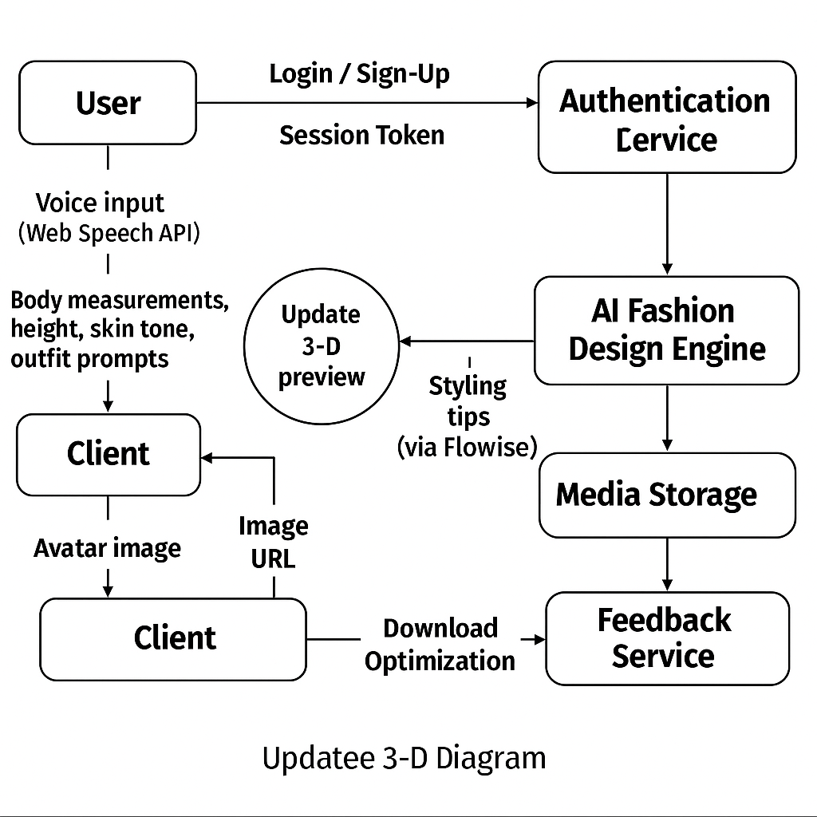**9.2 Sequence Diagram View**



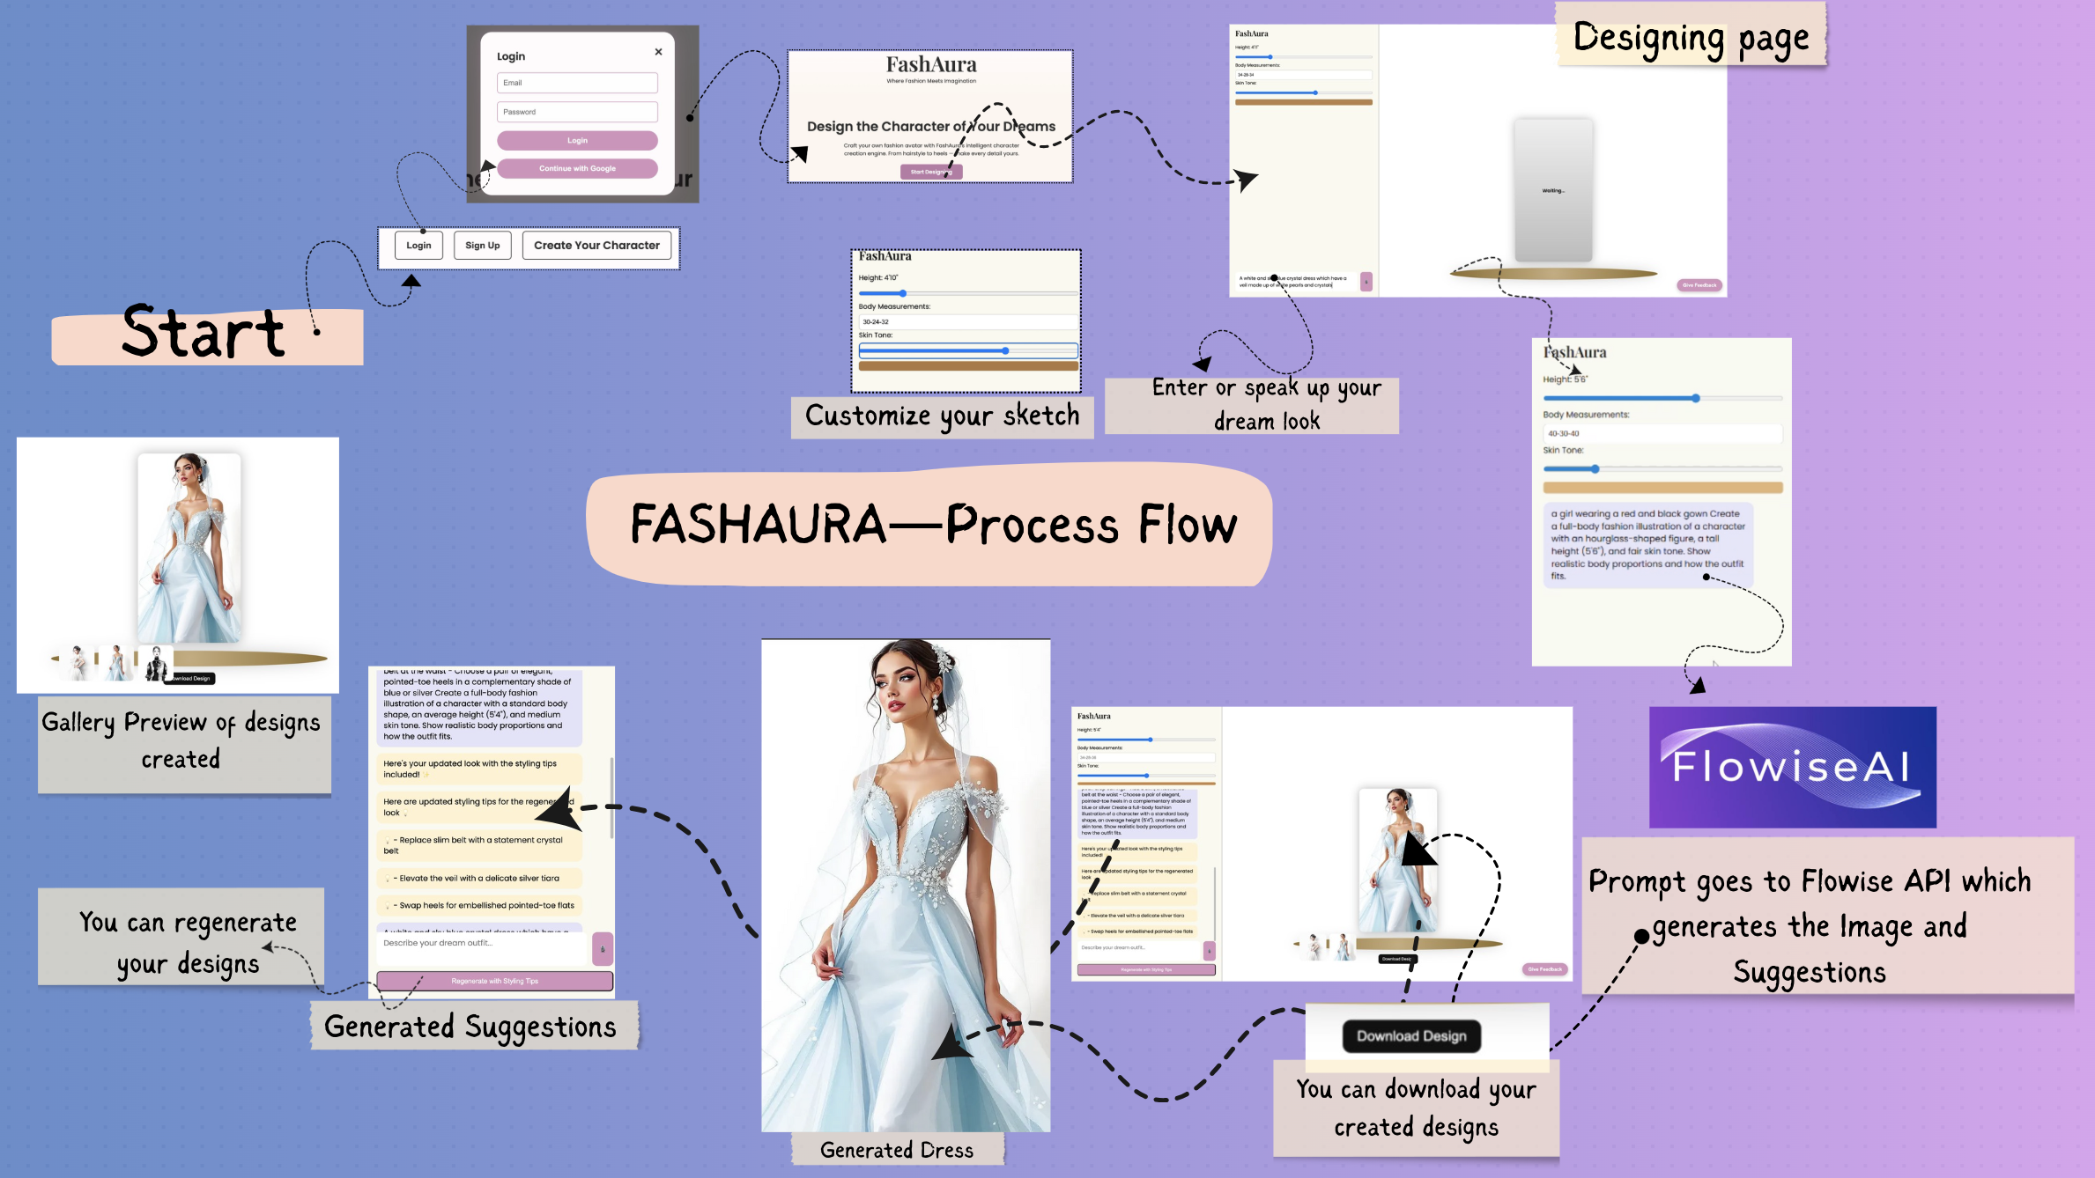

* 1. **Landing Page**

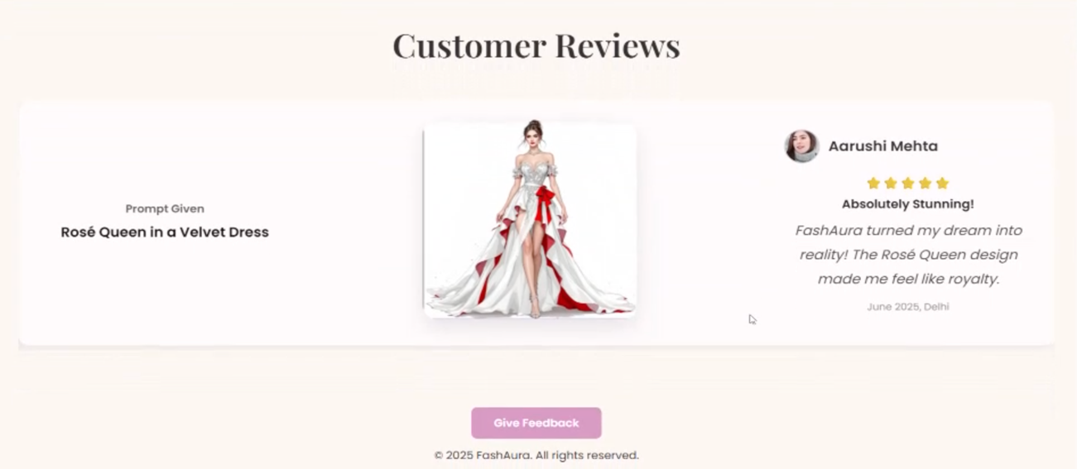

**9.4 Designing Page**

* 1. **Flowise AI Environment**

For generating the design

For suggesting the accessories

Speech to Text

**9.6 Feedback**

**9.7 Generated Designs**

